Tutorial 8
- What is a VLAN?
- How does a VLAN reduce network traffic?
- Why does inter-VLAN communication require a layer 3 device such as a router?
- Indicate the benefits of a VLAN?
- Distinguish between the following port types on a switch:
  - Access port
  - Trunk port
- Identify 3 trunk ports on Figure 1 below.
- Identify 2 access ports on Figure 1 below.
- Describe the operation of the IEEE 802.1Q trunking protocol.
- Describe how traffic flows from VLAN 10 to VLAN 20 (Computing1 → Media1) in the network shown in Figure 1 below. You may assume that the router and switch interfaces have been configured correctly.
- Distinguish between the following VLAN types:
  - Data VLAN
  - Native VLAN
  - Default VLAN
  - Management VLAN
  - Voice VLAN
- Describe 3 methods that can be used to assign VLAN membership to network devices.
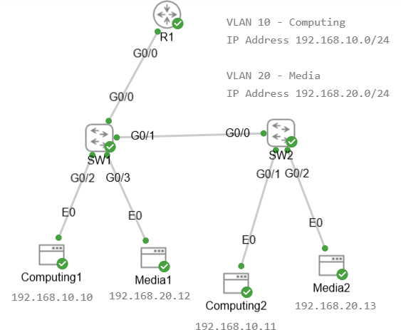
Figure 1 Wireshark frame capture

